Jawaban nomor 1

Script :

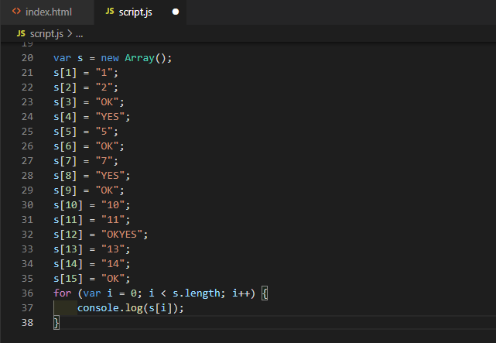

Hasil :

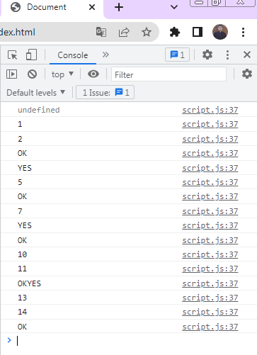

Jawaban nomor 4

SELECT *, (SELECT count(*) FROM employees WHERE

employees.department_id=departments.department_id) as finance FROM

departments

Jawaban nomor 5

ParentClass : List Employees

Attribute : Empid : Integer, Firstname : varchar, Lastname : varchar, JoinDate : date, Role : varchar, Basic Salary : number

Method : insert_data, update_data, delete_data, print_data, select_data, count_data

ChildClass1 : Tunjangan Sales

Attribute ChildClass1 : Bonus : varchar, Commission : varchar

Method ChildClass1 : insert_data, update_data, delete_data

ChildClass2 : Tunjangan Employee

Attribute ChildClass2 : Transportasi : varchar

Method ChildClass2 : insert_data, update_data, delete_data

ChildClass3 : Tunjangan Person

Attribute ChildClass3 : Makan : varchar

Method ChildClass3 : insert_data, update_data, delete_data